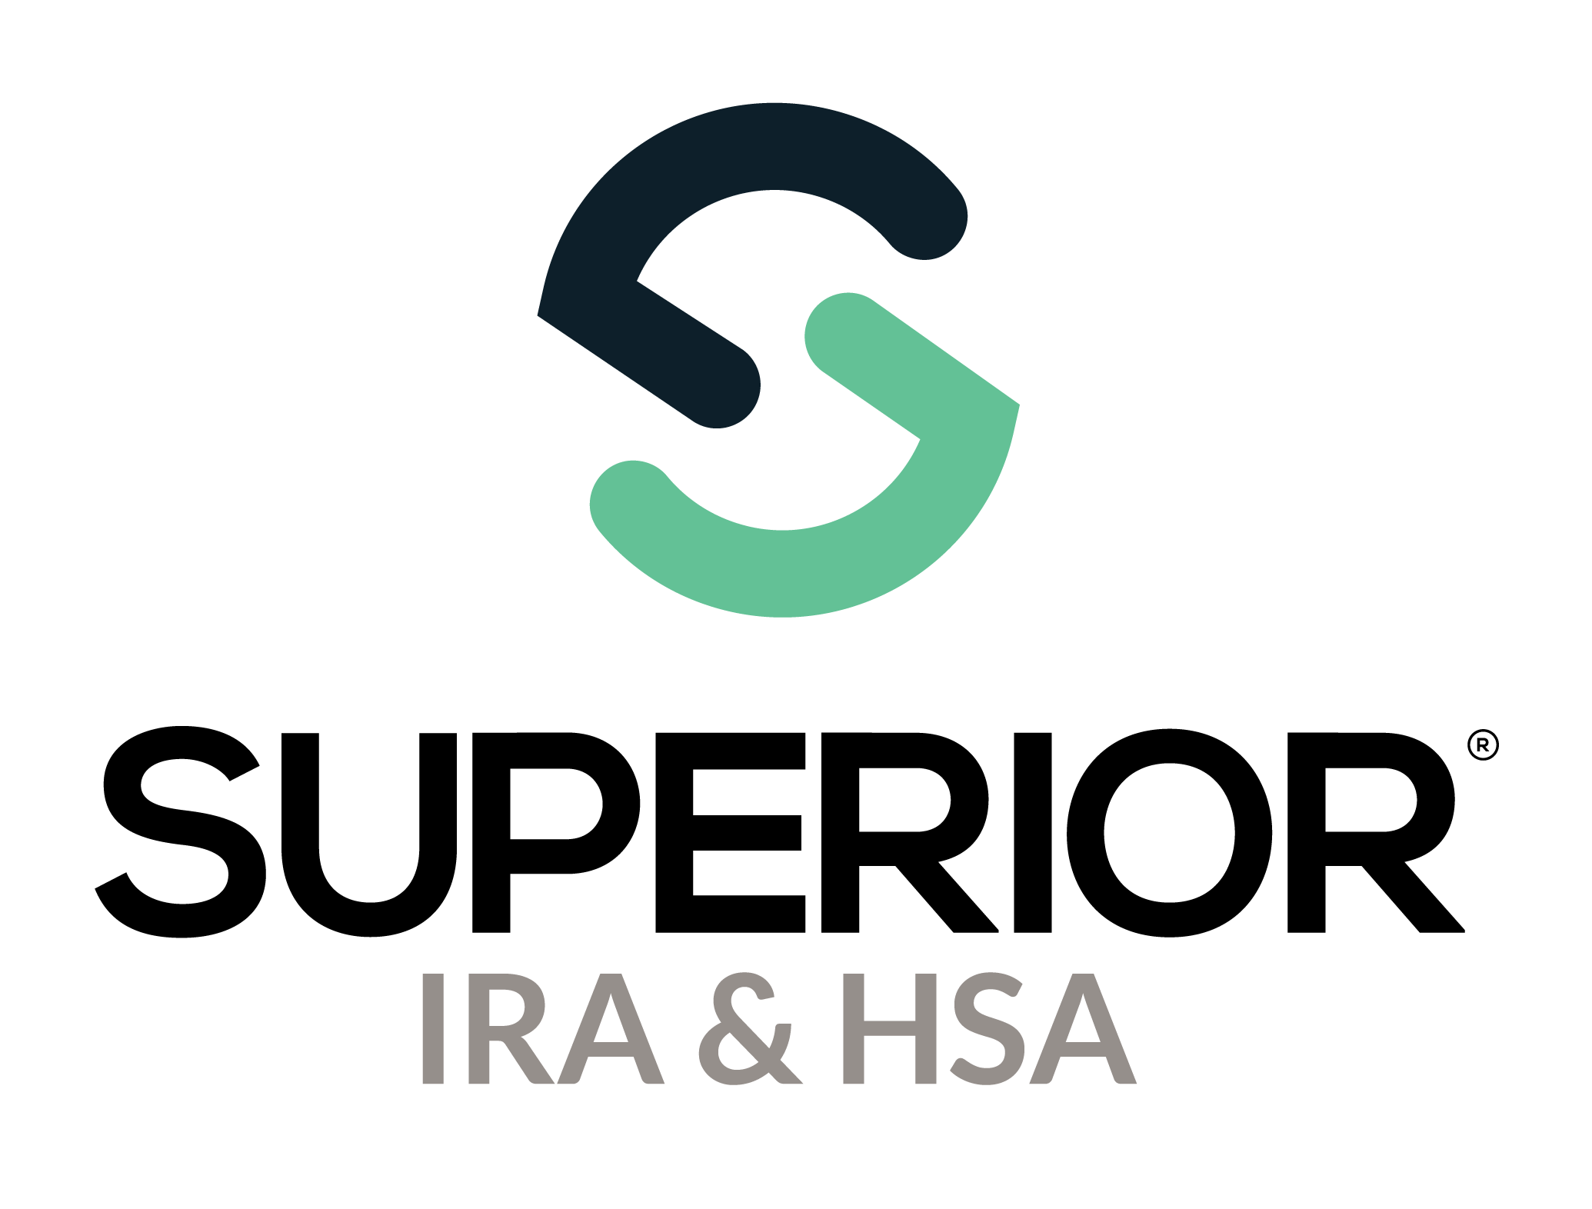

Beneficiary Claims Page Training Guide

Superior IRA & HSA® and the Superior IRA & HSA logo are registered trademarks of Superior IRA & HSA, LLC.

Table of Contents

Beneficiary Claims 3

Submit Beneficiary Claim 3

Provide Beneficiary Distribution Elections to Beneficiary(ies) 5

Upload Completed Beneficiary Distribution Elections 6

View Beneficiary Claims 8

Superior IRA & HSA Support 13

Chat 13

Call 13

Email 13

Help Center 13

# Beneficiary Claims

Users with a *Beneficiary Claims* role have access to this section. (This page is not applicable if your organization is enrolled in Superior’s **Silver solution**. It is only applicable to Superior’s **Green solution** and **Black solution**.)

Please note that Superior **will** **not** process claims in the following circumstances (but we will assist your organization with any questions).

* If the claim was already started (in house or with previous vendor) before your organization’s go-live date with Superior.
* If the owner’s date of death was more than one year ***before*** your go-live date with Superior.
* For instructions on processing claims that fall under these circumstances, click [here](https://superiorira.sharepoint.com/sites/SharedDocuments/Shared%20Documents/Customer%20Service%20&%20Operations/Beneficiary%20Claims/Procedures/Deaths%20Prior%20to%20Superior%20Agreement%20Date/Beneficiary%20Claims%20Instructions.pdf) to review Superior’s Beneficiary Claim Instructions.

For all other claims, follow the steps outlined within this guide to submit to Superior for processing.

Select **Beneficiary Claims** in the left navigation menu to submit and view beneficiary claims upon an account owner’s death.

## Submit Beneficiary Claim

* Search for and select the deceased account owner for whom you are submitting a beneficiary claim.
* Enter the **Owner’s** **Date of Death**.
  + If the claim is being submitted for a Traditional, SEP, or SIMPLE IRA of a deceased account owner that has died *after* their required beginning date (which is April 1st of the year following the year in which they attained RMD age), you’ll be asked to reconcile the distributions currently listed in Superior in the year of the owner’s death.
  + If the **Reconcile Distributions** section appears, simply add, remove, or edit the distributions listed to reflect the total amount distributed to the IRA owner before their death. This determines the remaining RMD in the year of death (if any) that must be distributed to the beneficiaries.
* Enter the Claims amount (which is the **Balance at Date of Death**) and then upload the owner’s death certificate by either dragging and dropping the document into the applicable section or by clicking **Choose File** to attach it from a specific file location.
* Attach the beneficiary designation form you have on file for the account. (If no form is on file, check the applicable box to indicate that no such designation is on file, and we will process the claim with the default beneficiaries.)

**Remember:** Review the form to ensure all beneficiary addresses are present and correct. In addition, make sure the beneficiary’s date of birth (DOB) is on the form. If a DOB or address needs to be provided to Superior or updated, please provide this information in the **Additional Information** section.

* Select your name from the **Representative** drop-down if it does not pre-populate.
* Enter information about the person who notified you of the owner’s death in the **Contact Information** section.
* Add any additional information and/or documents (including descriptions of those documents) as applicable.
  + Include a list of updated beneficiary addresses if the information provided on the beneficiary designation is outdated.
  + Include beneficiary DOB if not listed on the beneficiary designation form.
  + If any beneficiary named on the beneficiary designation form has also passed away, include a copy of that beneficiary’s death certificate.
  + If the beneficiary designation has been signed by a power of attorney (POA), include a copy of the POA for Superior to review.
  + If the beneficiary is a trust, provide a copy of the trust document that includes the name(s) of the trustee(s) as well as a list of trust beneficiaries, if applicable.
* Check the applicable box to indicate that you understand the claim will be processed based on the information submitted and click **Continue** to submit the claim.

Superior IRA & HSA will begin processing the claim and will notify your organization by adding a task when the forms are available to provide to the beneficiaries. If additional information is needed to process the claim, Superior will send an email requesting the information.

## Provide Beneficiary Distribution Elections to Beneficiary(ies)

After Superior prepares the **Beneficiary Distribution Elections** (or any other necessary documentation) and uploads the documents to the claim, a task will be added to your Dashboard with instructions to view/print the documents and provide to the beneficiaries (or other steps will be provided if additional action is required by your organization).

**Remember:** Superior does not mail the documents to the beneficiaries on your behalf. It is your organization’s responsibility to provide the documents to the beneficiaries.

You will receive an email notification when the task has been added for your review.

## Upload Completed Beneficiary Distribution Elections

Once a beneficiary has completed a **Beneficiary Distribution Election**,your organization will upload the completed/signed document to the **Upload Documents** section.

1. Click **Add New File**.
2. Select **Completed Beneficiary Distribution Election** from the **Document Type** drop-down.
3. Drag ‘n’ drop the signed election into the applicable section or click **Choose File** to locate the path of where the document is saved on your computer.
4. Enter a brief description of the document.
5. Click **Upload Document**.

Superior will receive an automatic email notification when a new document is uploaded to the claim. We’ll review the completed document and if everything appears correctly, we will add another task to your Dashboard with instructions of how to distribute the IRA assets to the beneficiary from your core system and how to log the distribution in Superior for reporting purposes.

Superior will also add the beneficiary to the claim, so they appear as a separate “card” in the **Beneficiaries** section. Click a card to view more details about the beneficiary such as

* Date of birth
* SSN
* Address
* Relationship to deceased owner
* Percentage of account designated
* Distribution option selected on their completed **Beneficiary Distribution Election** form (if it’s been received/processed)

After all **Beneficiary Distribution Elections** are received from the beneficiaries, uploaded to the claim, and processed by Superior, Superior will update the claim status from **Awaiting Election** to **Completed**.

## View Beneficiary Claims

Use this section to view the status of any beneficiary claims that your organization has either started to complete and hasn’t yet submitted (**Pending**) or has already submitted for processing.

The following statuses may appear.

* **Pending** – Claim is started but not yet submitted to Superior IRA & HSA for processing
* **Submitted for Processing** – Claim has been submitted to Superior IRA & HSA for processing
* **Awaiting Additional Info** – Additional information is needed from either your organization or the contact/beneficiary of the claim before claim processing can resume
* **Awaiting Election** – The **Beneficiary Distribution Election** has been uploaded to the claim for your organization to print and provide to the named beneficiary(ies)
* **Completed** – Your organization has uploaded the completed **Beneficiary Distribution Election** back to the claim and Superior IRA & HSA has added a task to the Dashboard with instructions for your organization to distribute the money to the beneficiaries
* **Not Processed –** Claims that will not be processed by Superior either because the date of the owner’s death is more than one year before your organization’s go-live date, the claim was already submitted/processed by your prior vendor, or your organization paid the assets to the beneficiary(ies) prior to Superior reviewing the claim. If a claim is updated to **Not Processed**, Superior will email your organization explaining why the status was changed.

Enter an asterisk (*) in the Search field and click the magnifying glass to search for all beneficiary claims that have been submitted to Superior.

Users may click the deceased owner’s name to view the beneficiary claim for that account.

The **Beneficiary Claim Information** section displays the data that was entered by the financial organization user when the claim was submitted.

Click the  icon within the **Comments** section to view all comments under a claim.

* To add a comment: Type your comment in the **Add a comment…** section and click the submit arrow.
* To edit an existing comment: Click the  icon next to the applicable comment. Select **Update** to make your edits and click the  icon to save those edits. (You may only edit your own comments.)
* To delete an existing comment: Click the  icon next to the applicable comment and select **Delete** to remove your comment. (You may only delete your own comments.)

**NOTE:** When a new comment is added or existing comment is edited, Superior is notified and will resume processing or contact you if additional information is needed.

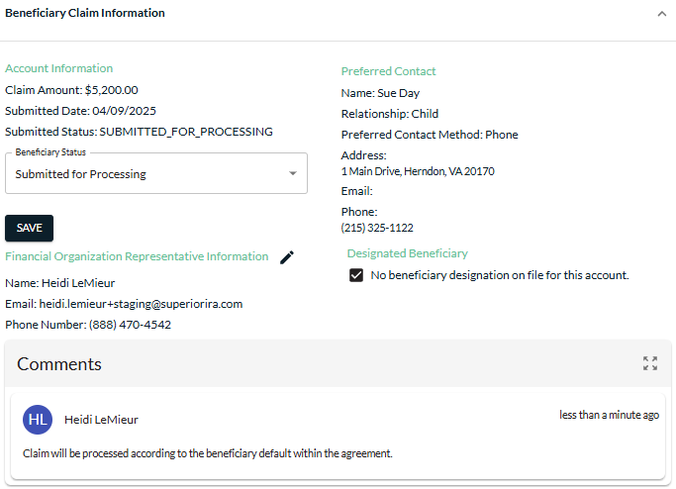

The **Fair Market Value** section displays the date-of-death balance provided by your organization, as well as the current/prior year RMDs for the IRA owner, if applicable.

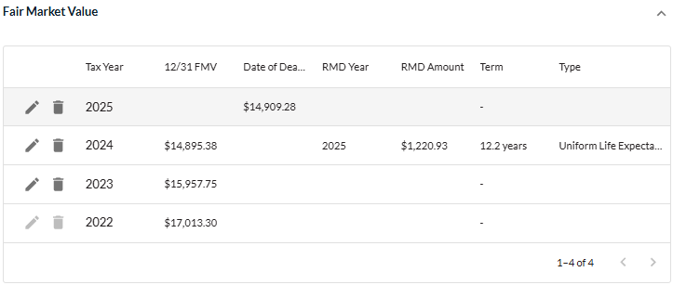

The **Distributions** section displays the distributions taken from the deceased owner’s account, as provided by your organization when submitting the beneficiary claim.

The **Uploaded Documents** section displays the documents that were submitted with the claim and any additional documents that were uploaded by Superior IRA & HSA or your financial organization.

1. View a document by clicking the **File Name** for the document.
2. Upload additional documents by clicking the **Add New File** icon.

# Superior IRA & HSA Support

## Chat

Chat with us directly from the Superior IRA platform. The chat bubble appears in the lower right corner of every screen.

## Call

Call us at 888-470-4542, Option 1.

## Email

Email us at [support@superiorira.com](mailto:support@superiorira.com).

## Help Center

Search for your answer directly from the chat bubble that appears in the lower right corner of every screen.

