

Dashboard Page Training Guide

Superior IRA & HSA® and the Superior IRA & HSA logo are registered trademarks of Superior IRA & HSA, LLC.

Table of Contents

Dashboard 3

Tasks 4

Pending Transactions 5

**Draft** 5

**Awaiting Signature** 6

**Pending Review** 7

**Awaiting Transfer** 7

Reports and Statistics 9

**Accounts Summary** 10

**Distributions and Deposits** 12

**Fair Market Values** 13

**Audit Reports** 13

**Pending Transactions** 14

Superior IRA & HSA Support 15

Chat 15

Call 15

Email 15

Help Center 15

# Dashboard

The dashboard will appear upon logging into the site. You may access the dashboard at any time by selecting the **Dashboard** tab in the left navigation menu.

## Tasks

Superior IRA & HSA will push out tasks for reminders and other communications to your organization. These tasks will be assigned to user roles as necessary. You may

* filter your tasks by **Complete** or **To-Do**;
* mark your tasks complete when finished (they will appear with a complete status on the dashboard); and
* reassign your tasks to other users at your financial organziation, by selecting another user listed under the **Assignee** drop down list; and
* click **Mark Complete** after a task has been completed to track your own progress (Superior is not notified when you complete a task).

If a **Resolve** button appears, the site will redirect you to the area within the platform where the task must be completed.

## Pending Transactions

Pending transactions will appear on your dashboard if you have the *Transactions* or *Transactions Administrato*r user role.

This section displays transactions that have been initiated in the system but are not yet completed because they were started and not finished, are awaiting a signature or transfer, or are pending review from a *Transactions Administrator*.

### **Draft**

If you start a transaction and leave it before completion, you will be asked to **Keep** or **Discard** your progress or click **Cancel** to return and finish the workflow.

If you **Discard** the transaction, the workflow will close and not information will be saved to the platform.

If you **Keep** the transaction, it will appear in the **Draft** section of the dashboard. You may

* filter your drafts by any of the column headers;
* click the **Type** field of a transaction to finish completing the workflow; or
* click **Discard** to delete the draft.

If you **Discard** the transaction, the workflow will close and no information will be saved to the platform.

### **Awaiting Signature**

If you complete a transaction up to the point of creating the PDF and navigate away from the workflow, you will be asked to **Keep** or **Discard** your progress or click **Cancel** to return and finish the workflow.

If you **Discard** the transaction, the workflow will close and no information will be saved to the platform.

If you **Keep** the transaction, it will appear in the **Awaiting Signature** section. You may

* filter the transactions by any of the column headers;
* click the **Type** field of the transaction awaiting signature to finish completing the workflow; or
* click **Discard** to delete the transaction.

If you **Discard** the transaction, the workflow will close and no information will be saved to the platform.

### **Pending Review**

Any transactions completed by users that do not have the *Transactions Administrator* role assigned to them will appear in the **Pending Review** queue for review from a *Transactions Administrator* before being applied to the system. This queue is only viewable to *Transactions Administrators*.

*Transactions Administrators* may

* filter the transactions by any of the column headers; and
* take any of the following steps to review the transaction:
  + click the **PDF** icon to review the completed form, then click **Done** after it turns green;
  + click the **Discard** (trash can) icon to delete the transaction if it should not be applied;
  + click the **Draft** (arrow) icon to return the transaction to the **Drafts** section, so the user who submitted the transaction can update the document; or
  + click the **Type** field of the transaction to update and finish the completed workflow.

### **Awaiting Transfer**

Whenever you complete the **Request Rollover/Transfer** workflow under the **Transactions** tab, the transaction will go into the **Awaiting Transfer** queue, pending completion until the money is received from the other financial organization.

When you receive the money from the other organization, take these steps in the **Awaiting Transfer** section.

* Click **Rollover/Transfer** to open the specific transaction. (Only click **Discard** if the transaction will no longer be completed.)

* Enter the amount of the rollover/transfer and the date assets were received. The account owner will not need to sign an additional document because a transfer/rollover request document was already signed, indicating which percentages to allocate to which investments.
* Click **Submit** to save the transaction.

## Reports and Statistics

The **Reports and Statistics** icon allows users to view the following reports for a certain time period of a specific tax year.

1. Accounts Summary
2. Distributions
3. Deposits
4. Fair Market Values
5. Audit Reports
6. Pending Transactions

### **Accounts Summary**

The **Accounts Summary** report displays a summary of all your accounts listed within the platform.

* Customize the report by selecting the date range to view the account activity.

* View all accounts opened and closed during the date range.
* Click any listed account to view that specific account’s details.
* Click **Export** to review the list of accounts in a spreadsheet format.

* Also view a summary of all currently open accounts within the platform.

### **Distributions and Deposits**

The **Distributions** and **Deposits** reports allow users to view a total report of the distributions or deposits made during a certain time period for specific account types.

* Select the Start date and End date to reflect the date range you wish to view.
* (For the **Deposits** report only) Select to view the **Itemized** or **Totals** version of the report.
  + **Itemized:** Displays all individual deposits added to the system.
  + **Totals:** Displays an aggregate total of all deposits of the same type added to the system, similar to how an account owner’s Form 5498 would appear.
* Select the specific account types you’d like to view, or leave the **Show accounts** field blank to view all account types.
* Click **Search**.
* Edit the tax years to display in the report by checking (or unchecking) the **Show Tax Years** boxes, if applicable.
* Click **Export** to create a .csv file of the report.
* Click any listed account to view that specific account’s details.

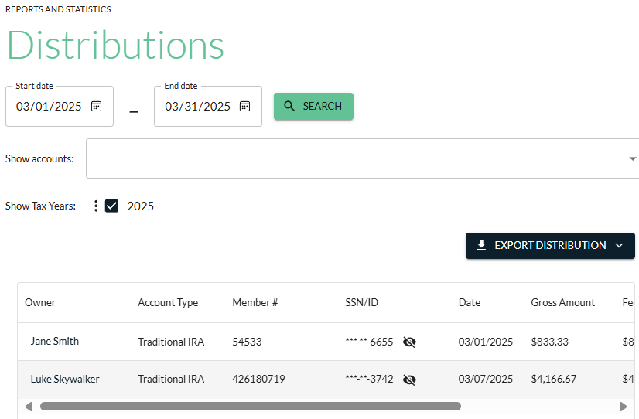

### **Fair Market Values**

The **Fair Market Values** report allows you to view the December 31 account balances of the selected account types that have been entered into the platform. The report also includes an account owner’s RMD amount, if applicable.

* Select the tax year of the fair market value (FMV) you’d like to view.
* Select the specific account types you’d like to view, or leave the **Show accounts** field blank to view all account types.
* Select additional FMV filter options to only display accounts that have
  + $0 or no FMV listed in the site;
  + FMV listed in the site for the selected year;
  + Date of Death value listed for the selected year; or
  + Date of Death value listed for the current year.
* Click **Search**.

### **Audit Reports**

The **Audit Reports** allow you to view an audit trail for the date range entered of any changes made to account owner information (i.e., name, taxpayer ID, date of birth, address) and which user made those changes.

### **Pending Transactions**

The **Pending Transactions** report provides a list of all transactions sitting in the Pending Review queue on the dashboard, awaiting review/approval from a user with the *Transactions Administrator* role.

# Superior IRA & HSA Support

## Chat

Chat with us directly from the Superior IRA platform. The chat bubble appears in the lower right corner of every screen.

## Call

Call us at 888-470-4542, Option 1.

## Email

Email us at [support@superiorira.com](mailto:support@superiorira.com).

## Help Center

Search for your answer directly from the chat bubble that appears in the lower right corner of every screen.

