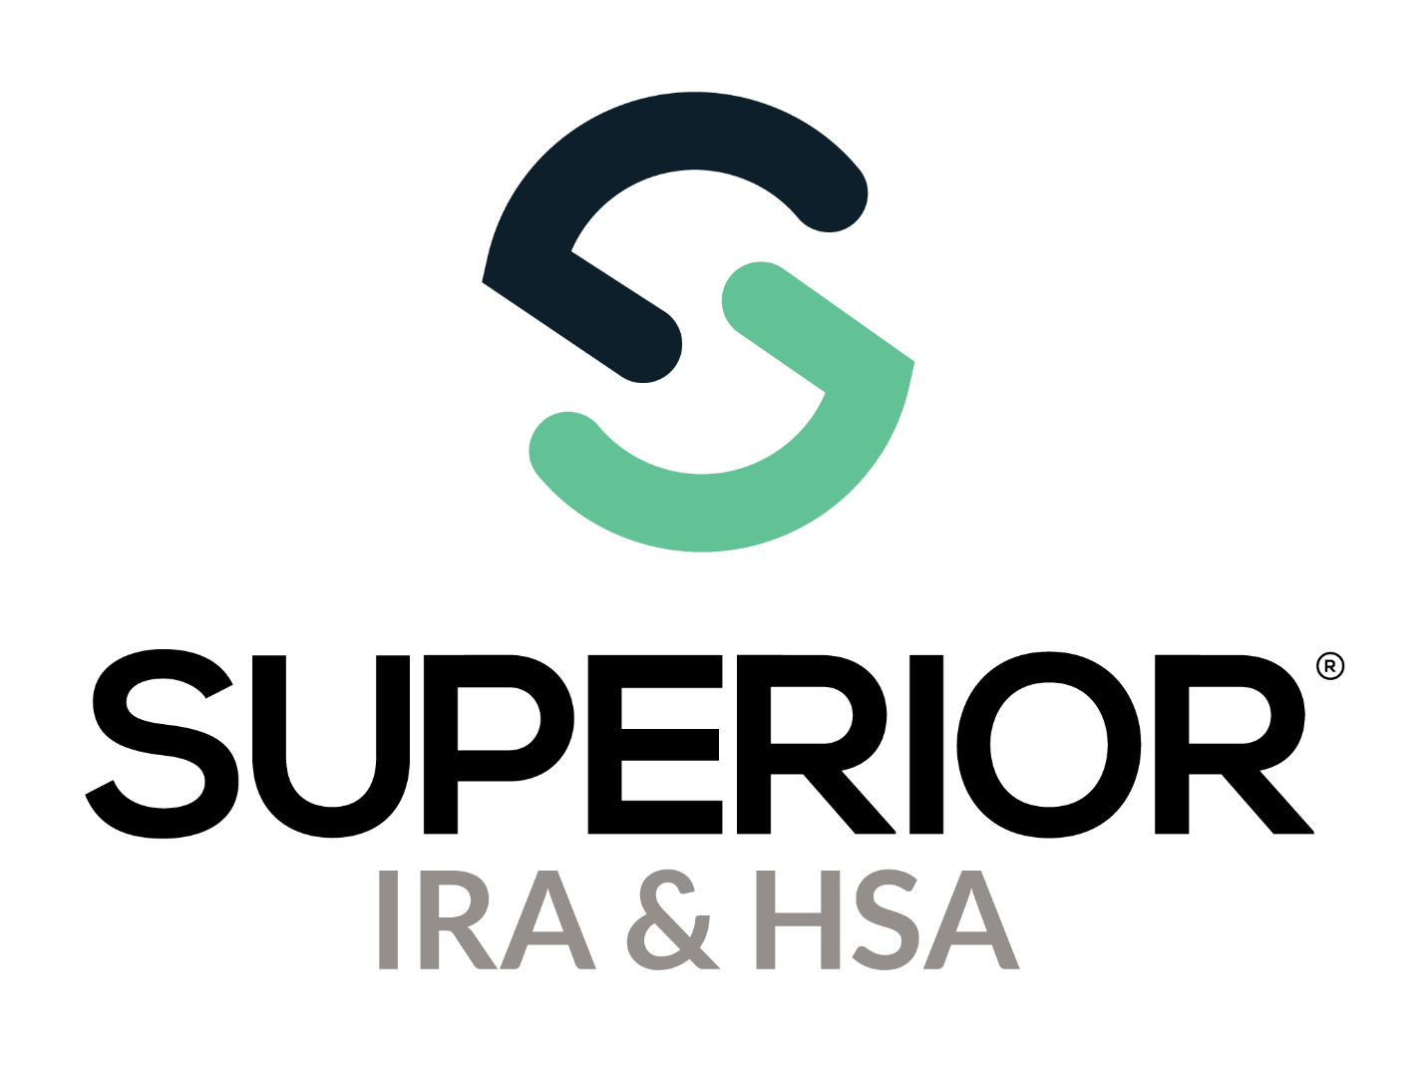
Data Gathering Instructions

Superior IRA & HSA® and the Superior IRA & HSA logo are registered trademarks of Superior IRA & HSA, LLC.

Our goal is to make the data gathering steps as simple as possible.
The chart provided within these instructions outlines the data that is required to be added to the Superior IRA & HSA® platform, along with steps to retrieve this information using your organization’s current data listed on reports from Ascensus.
We recommend pulling your data at the end of day and keeping track of the date that you retrieved this information in case additional transactions occur after your initial upload.
Upon downloading your existing account owner data from Ascensus at the initial start of this project, upload the spreadsheets under the Organization Settings>Organizational Documents section of the Superior IRA & HSA platform.
Superior will begin to apply the data to the platform and will reach out by email with any data gathering questions until all data has been applied and verified by your organization.

To add additional transactions received by your financial organization after your initial upload, please review our Adding Additional Data Received After Initial Upload to Superior section at the end of this document.

Data Gathering Reports to Pull from Ascensus
Follow the instructions provided below to pull a report for each piece of data gathering required from Superior. Once retrieved, upload these reports to the Superior platform under Organization Settings>Organizational Documents.

IMPORTANT: Before pulling any of these reports from Ascensus, confirm that Social Security number (SSN) masking is disabled for your organization’s reports. Take these steps.
- Click your organization’s name in the upper right corner of the IRAdirect homepage.
- Click the Reporting tab.
- Confirm that the selection for the Account Owner SSN on Reports drop-down reads, “Display Full SSN”.
- Change the selection, if necessary, and click Save at the bottom of the page.
What’s Needed | Details
Account Owner Information | Provide the information outlined below.  - All open Traditional, Roth, SEP, SIMPLE IRAs, Health Savings Accounts (HSAs), and Coverdell Education Savings Accounts (ESAs)  - All closed Traditional, Roth, SEP, SIMPLE IRAs, HSAs, and ESAs from January 1 – current day of current year  - Only include plan level  - Do not add each investment opened under the plan  How to Pull Data from IRAdirect  Pull two versions of the Account Owner List, found under the Reports link from the IRAdirect homepage.  Version #1:  - Select Owners from the Owner/Beneficiary drop-down.  - Select Yes from the Exclude Deceased drop-down.  - Leave all other fields unchanged.  - Select Output to Excel.  - Save as “Account Owner List Open”.  Version #2:  - Select Owners from the Owner/Beneficiary drop-down.  - Enter 01/01/2024 in the Account Closed Date (start) field.  - Enter 12/31/2024 in the Account Closed Date (end) field.  - Select No from the Exclude Closed Accounts drop-down.  - Select Yes from the Exclude Deceased drop-down.  - Leave all other fields unchanged.  - Select Output to Excel.  - Save as “Account Owner List Closed in 2024”.
Deceased Account Owner Information | Provide all active deceased owner accounts and those closed in the current year.  How to Pull Data from IRAdirect  Pull two versions of the Account Owner List, found under the Reports link from the IRAdirect homepage.  Version #1:  - Select Owners from the Owner/Beneficiary drop-down.  - Enter 01/01/1900 in the Date of Death (start) field.  - Enter 12/31/2024 in the Date of Death (end) field.  - Select No from the Exclude Deceased drop-down.  - Leave all other fields unchanged.  - Select Output to Excel.  - Save as “Deceased Account Owner List Open”.  Version #2:  - Select Owners from the Owner/Beneficiary drop-down.  - Enter 01/01/1900 in the Date of Death (start) field.  - Enter 12/31/2024 in the Date of Death (end) field.  - Enter 01/01/2024 in the Account Closed Date (start) field.  - Enter 12/31/2024 in the Account Closed Date (end) field.  - Select No from the Exclude Closed Accounts drop-down.  - Select No from the Exclude Deceased drop-down.  - Leave all other fields unchanged.  - Select Output to Excel.  - Save as “Deceased Account Owner List Closed in 2024”.
Inherited Account Owner Information | Provide all active inherited account owner information and those closed in the current year, along with the original deceased owner details.  How to Pull Data from IRAdirect  Pull two versions of the Account Owner List, found under the Reports link from the IRAdirect homepage.  Version #1  - Select Beneficiary from the Owner/Beneficiary drop-down.  - Select Yes from the Exclude Deceased drop-down.  - Leave all other fields unchanged.  - Select Output to Excel.  - Save as “Beneficiary Owner List Open”.  Version #2:  - Select Beneficiary from the Owner/Beneficiary drop-down.  - Enter 01/01/2024 in the Account Closed Date (start) field.  - Enter 12/31/2024 in the Account Closed Date (end) field.  - Select No from the Exclude Closed Accounts drop-down.  - Select Yes from the Exclude Deceased drop-down.  - Leave all other fields unchanged.  - Select Output to Excel.  - Save as “Beneficiary Owner List Closed in 2024”.
Designated Beneficiary and Responsible Individual Information (Coverdell ESAs) | Provide the following Responsible Individual (RI) data for each ESA (can be provided in a separate spreadsheet).  - Designated Beneficiary First & Last Name  - RI First & Last Name  - RI Phone Number (optional)  - RI Email (optional)  - RI Address Line 1  - RI Address Line 2  - RI City  - RI State  - RI Zip  - Does the RI remain the RI after the designated beneficiary reaches the age of majority (yes or no)  - Can the RI change the designated beneficiary to another family member (yes or no)  How to Pull Data from IRAdirect  There is no report available in IRAdirect to retrieve this information.
Fair Market Values | Provide the account balance on December 31 of last year.  How to Pull Data from IRAdirect  Pull the Fair Market Value report, found under the Reports link from the IRAdirect homepage.  - Select No from the Exclude Closed Accounts drop-down.  - Select No from the Exclude Deceased Members drop-down.  - Select Output to Excel.  - Save as “All FMVs”.
Distributions | Provide all reportable year-to-date distributions.  How to Pull Data from IRAdirect  Pull the Withdrawals report, found under the Reports link from the IRAdirect homepage.  - Enter 01/01/2024 in the Withdrawal date (start) field.  - Enter 12/31/2024 in the Withdrawal date (end) field.  - Leave all other fields unchanged.  - Select Output to Excel.  - Save as “Current Year Withdrawals”.
Contributions | Provide all reportable year-to-date deposits (i.e., regular, rollover, conversion, recharacterization).  How to Pull Data from IRAdirect  Pull two versions of the Contributions report, found under the Reports link from the IRAdirect homepage.  Version #1  - Enter 01/01/2024 in the Date Money Entered (start) field.  - Enter 12/31/2024 in the Date Money Entered (end) field.  - Select 2024 from the Tax Year drop-down.  - Select Output to Excel.  - Save as “Current Tax Year Contributions”.  Version #2  - Enter 01/01/2024 in the Date Money Entered (start) field.  - Enter 12/31/2024 in the Date Money Entered (end) field.  - Select 2023 from the Tax Year drop-down.  - Select Output to Excel.  - Save as “Prior Tax Year Contributions”.  NOTE: Only HSA prior-year deposits will be added to the Superior platform to ensure accurate reporting. Prior-year HSA deposits are reported two years in a row, per IRS instructions. For example, HSA deposits made in 2024 for 2023 are reported in Box 3 of the 2023 Form 5498-SA and reported in Box 2 of the 2024 Form 5498-SA.
Recurring Distribution Schedules | Provide required minimum distribution elections, 72t payment elections, inherited IRA distribution elections, and any Roth IRA recurring distributions.  *Add any Roth IRA recurring distributions to these lists (since Ascensus did not track these distributions).  How to Pull Data from IRAdirect  Pull two versions of the Scheduled Payment List, found under the Reports link from the IRAdirect homepage.  Version #1:  - Make no changes to the fields.  - Select Output to Excel.  - Add an additional column to indicate the direct deposit account, if applicable (checking, savings, etc.)  - Save as “Scheduled Payments – Entire Year”.  Version #2:  - Select the current month from the Beginning Month (Current Year) drop-down.  - Select the current month from the Ending Month (Current Year) drop-down.  - Select Output to Excel.  - Add an additional column to indicate the direct deposit account, if applicable (checking, savings, etc.)  - Save as “Scheduled Payments – Current Month”.
Users & Roles | Add your organization’s users to the Superior IRA & HSA platform individually by following the steps in the “How to Add Users Individually to Platform” section or use a batch file as outlined in the “How to Add Users with Superior Templates” section.  To pull a list of your organization’s current users with IRAdirect access, follow the steps in the “How to Pull Data from IRAdirect” section.  How to Add Users Individually to Platform  A User Administrator at your organization will follow these steps:  - Click Users from the left navigation menu in the Superior platform.  - Click the Add User button.  - Provide the following details.  - First name  - Last name  - Phone number formatted as (###) ###-####  - Email address  - Job title  - Notification preference (all notifications, for user roles only, or none)  - Select the user’s roles & permissions within the Superior platform  - Beneficiary Claims: Ability to submit and process beneficiary claims.  - Data Processor: Ability to upload and process the organization’s imported files.  - Recurring Distributions Administrator: Ability to review scheduled distributions and notification mailing lists and edit settings for recurring distributions.  - Site Administrator: Ability to add permissions to administer an organization, including deleting accounts, editing organizational data, updating investments, etc.  - Tax Reporting: Ability to review/submit the organization’s end of year tax reporting.  - Transactions: Ability to complete typical teller actions, such as adding new accounts and transactions through the transaction workflows.  - Transactions Administrator: Ability to review and override some transaction validations from other users.  - User Administrator: Ability to add, update, and remove users from an organization.  - Check the box to verify and complete the user registration.  How to Add Users with Superior Templates  - Click Data Import from the left navigation menu in the Superior platform.  - Click Add Users.  - Click the Import Users button.  - Click the Click Here link to download the “Users” template.  - Add user data to the spreadsheet, referring to the “Field Definitions” tab for formatting details.  - Save spreadsheet and upload under Organization Settings>Organizational Documents of the Superior platform.  How to Pull Data from IRAdirect  A Security Administrator for your organization may take these steps to pull your User Report.  - Click My Services in the Maintenance Tools section of the IRAdirect homepage.  - Click User Report in the User Management box.  - Click Export to Excel Spreadsheet to export the report to a spreadsheet format.  - Reformat the spreadsheet to match the template available in the Superior platform (under Data Import>Add Users>Click Here), where you’ll provide the required information and reflect the roles that should be assigned to each user within the Superior IRA & HSA platform (outlined on the previous page).

Additional Reports to Pull Before Termination with Ascensus
Superior recommends pulling the following reports from IRAdirect before terminating with Ascensus. These reports do not need to be uploaded to Superior. Instead, please follow the instructions provided below for each report.

What’s Needed | Details
RMD Scheduled Payment Status List | Follow these steps to pull a list of your IRA owners who received an RMD notification mailing from Ascensus in February of the current year but do not yet have an election saved to IRAdirect.  Do not upload this report to Superior. It is only for your organization’s reference should any follow-up be required internally.  How to Pull Data from IRAdirect  Pull the RMD Scheduled Payment Status Report, found under the Reports link from the IRAdirect homepage.  - Make no changes to the fields.  - Select Output to Excel.  - Save as “RMD Scheduled Payment Status Report” and review the instructions below.  Ascensus normally defaults these IRA owners to an election in either December or March (depending on their age). If these IRA owners are not defaulted to an election before you provide Superior with your Scheduled Payment Lists, you’ll want to contact these owners to make sure they receive their current year RMD and establish an election on the Superior platform.  If an IRA owner listed on this report does not have a recurring distribution added to the Superior platform before Superior completes your RMD notification mailing in February of the following year, the IRA owner will be included in the Superior mailing. However, you’ll want to make sure the IRA owner does not miss satisfying the current year RMD, if possible.
Current & Previous Tax Year Information Reports (1099-R, 1099-Q, 1099-SA, 5498, 5498-ESA, 5498-SA, as applicable) | Follow these steps to pull a list of up to the past seven years of tax data that Ascensus has completed on behalf of your organization.  Do not upload this report to Superior. It is only for your organization’s reference should any previous year tax form corrections be required by your organization.  How to Pull Data from IRAdirect  Pull the Current Tax Year (1099-R, 1099-Q, 1099-SA, 5498, 5498-ESA, & 5498-SA) Information Report (as applicable), found under the Reports link from the IRAdirect homepage.  - Ensure the Printed Date From and Printed Date To drop-downs range from the earliest printed date to the latest printed date.  - Select Output to Excel.  - Save as “Current Tax Year ‘XXXX’ (Tax Form Type – 1099-R, 1099-Q, 1099-SA, 5498, 5498-ESA, or 5498-SA)” and save the file for your organization’s records.  How to Pull Data from IRAdirect  Pull the Previous Tax Year (1099-R, 1099-Q, 1099-SA, 5498, 5498-ESA, & 5498-SA) Information Report (as applicable), found under the Reports link from the IRAdirect homepage.  - Select the applicable Tax Year from the drop-down (retrieve information for up to the last seven years).  - Select All from the Form Type drop-down.  - Select Output to Excel.  - Save as “Previous Tax Year ‘XXXX’ (Tax Form Type – 1099-R, 1099-Q, 1099-SA, 5498, 5498-ESA, or 5498-SA)” and save the file for your organization’s records.
Death Claim Status Report | Follow these steps to pull a list of current death claims being processed by Ascensus.  Do not upload this report to Superior. It is only for your organization’s reference should any follow-up be required to finish processing these claims after your organization is live with Superior.  How to Pull Data from IRAdirect  Pull the Death Claim Status Report, found under the Reports link from the IRAdirect homepage.  - Select Output to Excel.  - Save as “Death Claim Status Report”.  - Review any outstanding claims listed on the report and retrieve/print all documentation submitted to and provided by Ascensus from the death claim in IRAdirect.  Your organization will be required to finish the processing of any death claims that were not processed by Ascensus before your termination. If you need help determining the payment options offered to any beneficiaries, you may contact us for assistance.

Adding Additional Data Received After Initial Upload to Superior
Remember the date that you pull your initial data to upload to the Superior platform. Any transactions processed after this date but before your “live” date with Superior, may be added to the platform using one of the following methods:
- Complete the applicable transaction workflow under the Transactions page of the Superior platform to add the information to the specific account owner’s account.

OR

- Follow the steps outlined on pages 3–8 to pull the additional information and enter it into the applicable templates provided by Superior under the Data Import page of the platform.
  - Only retrieve information that was added after the date you initially pulled data through your “live” date with Superior.
  - Upload the reports under the Data Import page for the specific additional data you will be uploading (e.g., Add/Update Accounts, Add/Update Deposits, Add/Update Distributions).
  - Review the status of the uploaded file to confirm that no errors applied.
  - Correct any errors, as needed, under the Data Import page until no errors remain.
Contact Us
As always, if you have any questions, we’re happy to assist! Please contact us Monday through Friday from 8:00 a.m. to 5:00 p.m. Central Time, using one of the following methods:
- Chat feature located in the bottom right corner of the Superior IRA & HSA platform
- Email at support@superiorira.com
- Call us at 888.470.4542, option 1 for Customer Service

