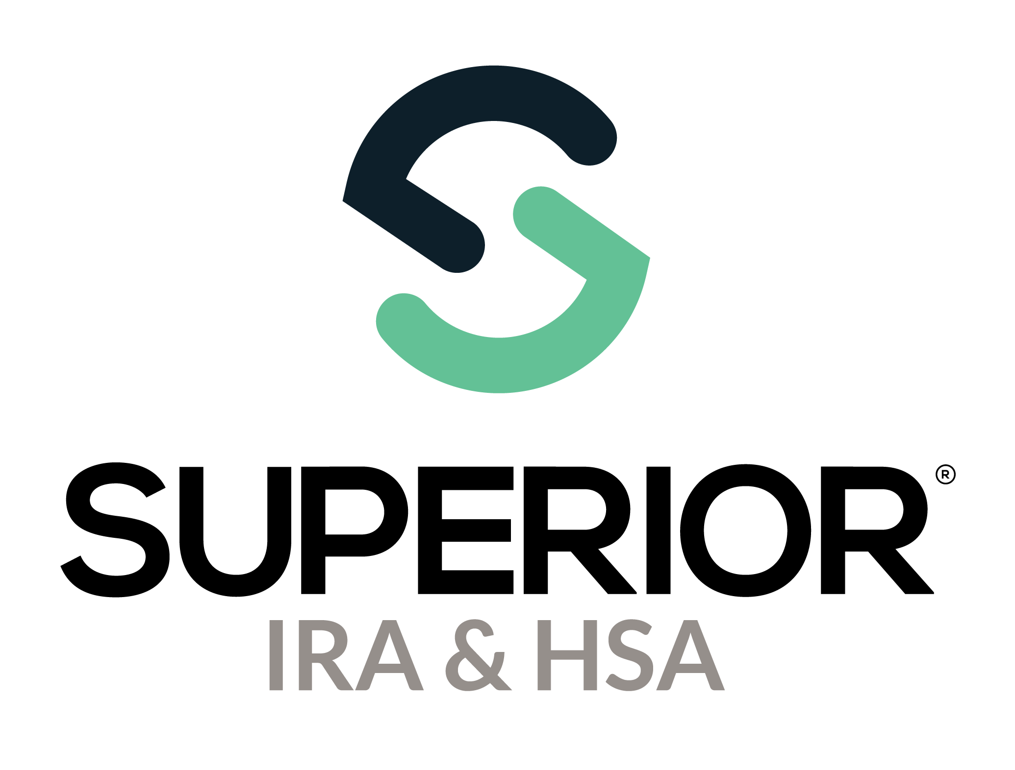

Login, Edit Profile, & Chat Bubble

Training Guide

Superior IRA & HSA® and the Superior IRA & HSA logo are registered trademarks of Superior IRA & HSA, LLC.

Table of Contents

New User Access and Verification 3

Logging In to Superior IRA 3

Editing Your Profile 4

Superior IRA & HSA Support 6

Chat 6

Call 6

Email 6

Help Center 6

# New User Access and Verification

Your financial organization’s *User Administrator(s)* will set up all new users by navigating to the **Users** tab found in the left navigation menu. The **Users** tab is not accessible nor displayed for any other user role type.

If you are a *User Administrator* for your organization, review the Users Page Training Guide for instructions about adding users to the site.

After you are added to the system by the *User Administrator*, you will receive two emails from [login@app.superiorira.com](mailto:login@app.superiorira.com)—one to verify your email address and the other to set up your password.

# Logging In to Superior IRA

1. Go directly to the login screen at <https://app.superiorira.com/>, or go to [www.superiorira.com](http://www.superiorira.com) and click **Login** in the upper right corner of the screen.

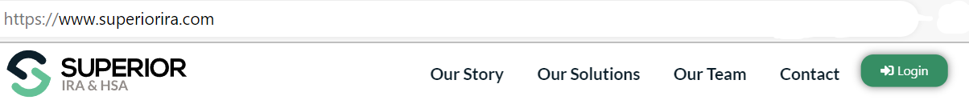

1. Enter your email address and click **Continue**.
2. Enter your password and click **Continue**.

1. Click **Forgot password** if you need to reset your password or contact your *User Administrator* to send you a reset password email. If reset, you’ll receive an email from [login@app.superiorira.com](mailto:login@app.superiorira.com) to proceed with changing your password.

# Editing Your Profile

Your profile consists of your first and last name, phone number, email address, job title, branch location, and notification preference.

All users may edit their user profile information, except for the email address used to establish their user account. If an email address needs to be changed for a user, a *User Administrator* must delete the account associated with the old email address and establish a new account for the user. Review the Users Page Training Guide for instructions about deleting/adding users to the site.

To edit your profile, take these steps after logging into the site.

1. Click the **Profile** icon in the upper right corner.

1. Select **Edit Profile**.

1. Expand the **Edit User Information** section to edit any details and click **Continue**.
2. Expand the **Edit Role & Permissions** section to edit your roles and permissions and click **Continue**. (Only available to *User Administrators*.)

# Superior IRA & HSA Support

## Chat

Chat with us directly from the Superior IRA platform. The chat bubble appears in the lower right corner of every screen.

## Call

Call us at 888-470-4542, Option 1.

## Email

Email us at [support@superiorira.com](mailto:support@superiorira.com).

## Help Center

Search for your answer directly from the chat bubble that appears in the lower right corner of every screen.

