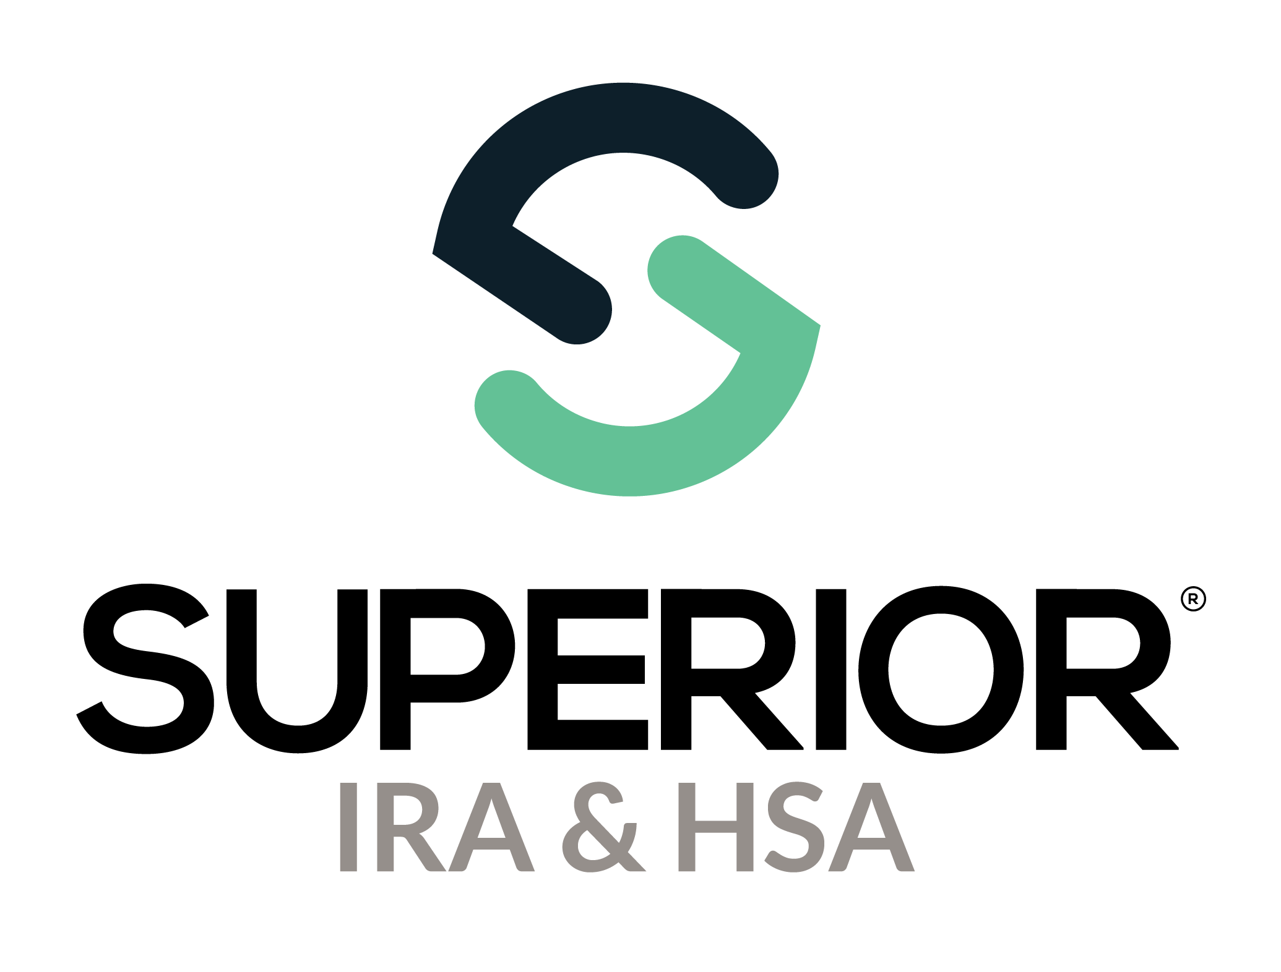

Users Page Training Guide

Superior IRA & HSA® and the Superior IRA & HSA logo are registered trademarks of Superior IRA & HSA, LLC.

Table of Contents

Users 3

Creating a New User 3

Editing an Existing User 6

Resetting a User’s Password 8

Deleting a User 8

Superior IRA & HSA Support 9

Chat 9

Call 9

Email 9

Help Center 9

# Users

Users with a *User Administrator* role have access to the **Users** page of the Superior IRA & HSA® platform.

Select **Users** in the left navigation menu to view, add, edit, and delete users. (If you are not a *User Administrator,* you will not have**Users** as an option onthe left navigation menu.)

You may also click **Export Users** to export a list of the users currently added to the platform.

## Creating a New User

To add a new user to the site, a *User Administrator* will follow these steps.

1. Click **Add User**.

1. Enter the First Name, Last Name, Phone Number, Email, and Job Title.
2. Select the appropriate branch that corresponds with the user’s primary work location in the **Branch** field. (The branches displayed in the drop-down are based on the information entered by your organization’s *Site Administrator* under the **Organization Settings** tab.)
3. Turn on **Designate as Main Contact** only if the user is the primary contact for your organization.
4. Select one of the following preferences for the user to receive notifications from Superior IRA & HSA.
   * All notifications
   * Notifications based on my user roles
   * Do not send me notifications
5. Click **Continue**to select the user’sRoles and Permissions.

1. Check the roles and permissions the user needs access to. The permissions are listed under each role type.

1. Check the box to confirm the new user is authorized by the organization.
2. Click **Continue** to save the user.

After adding a user to the system, that user will receive two emails from [login@app.superiorira.com](mailto:login@app.superiorira.com)—one to verify their email address and the other to set up their password.

## Editing an Existing User

*User Administrators* may edit any information for an existing user (including their own user roles) by following these steps.

1. Click the specific user’s name from the **Users** tab.

1. Expand the **User Information** section and click **Edit Details** to edit a user’s first name, last name, phone number, job title, branch location, or notification preference.

**Note:** A user’s email address cannot be edited. If a user’s email address has changed, follow the steps in the Creating a New User section to establish an account with the new email address, then delete the account with the old email address using the steps provided in the Deleting a User section.

1. Expand the **Role & Permissions** section and click on **Edit Details** to edit a user’s roles.

## Resetting a User’s Password

*User Administrators* may reset a user’s password if the user is having trouble accessing the **Forgot Password** link on the login page.

1. Click the user’s name from the **Users** tab.
2. Expand the **Roles & Permissions** section for the user.
3. Click **Reset Password**.

## Deleting a User

*User Administrators* may delete a user’s access to the Superior platform if they no longer work in the IRA department, have left the organization, or their email address has changed.

1. Find the user’s name in the table and scroll to the right.
2. Click **Delete**.

# Superior IRA & HSA Support

## Chat

Chat with us directly from the Superior IRA platform. The chat bubble appears in the lower right corner of every screen.

## Call

Call us at 888-470-4542, Option 1.

## Email

Email us at [support@superiorira.com](mailto:support@superiorira.com).

## Help Center

Search for your answer directly from the chat bubble that appears in the lower right corner of every screen.

